DA MINI PROJECT

TEAM MEMBERS: NAVBILA K (22ADR071) , RAMYA K (22ADR085) , SRIDHAR S (22ADR102)

1.What is the overall global trend in temperature change from 1961 to 2022?

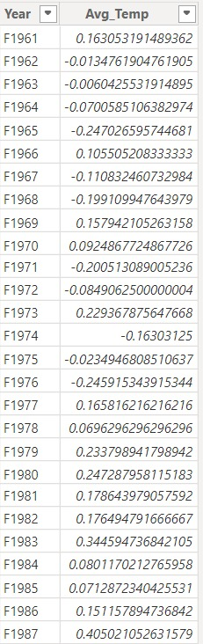

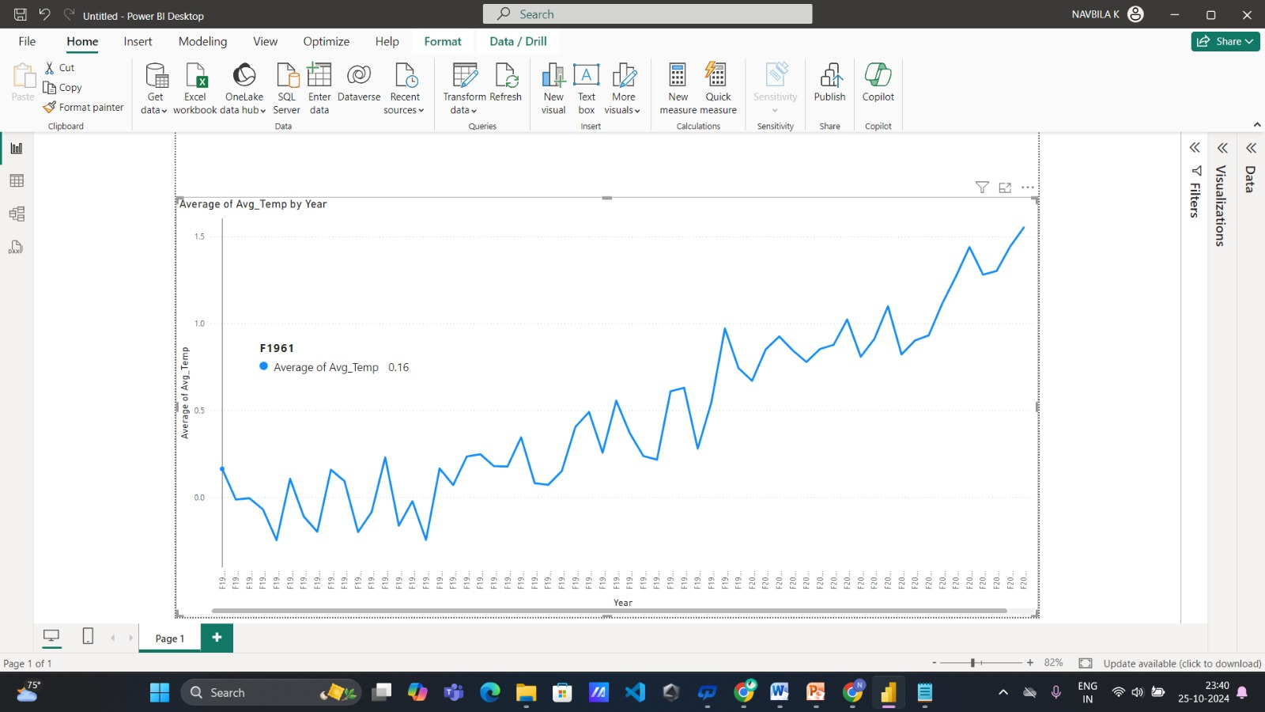

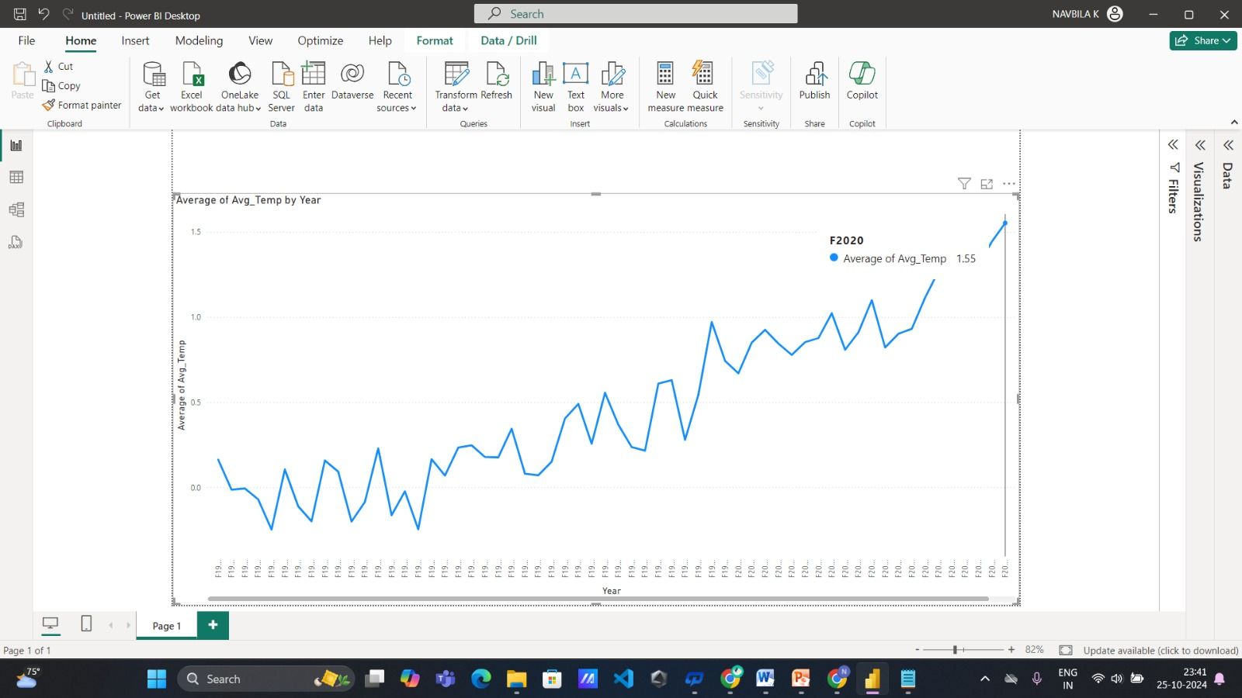

**Inference:** The average temperature increased from approximately 0.16 in 1961 to 1.55 in 2020, indicating significant warming over the decades. This trend highlights the potential impact of climate change and warrants further investigation.

**2.How do temperature changes vary across different regions or continents over the observed period?**

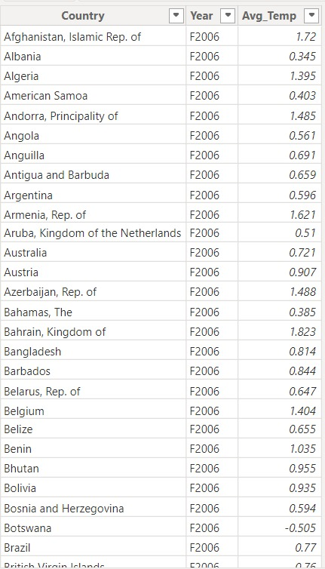

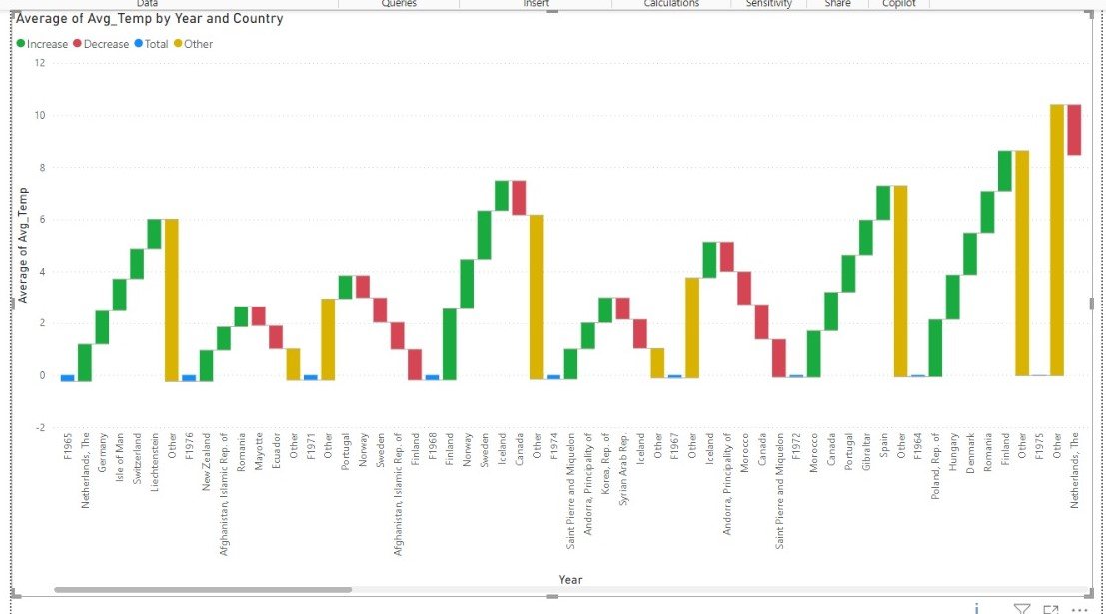

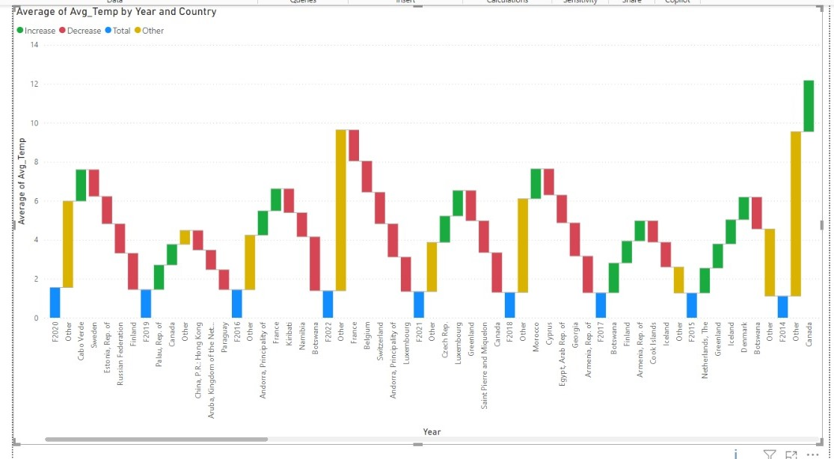

**Inference**: The temperature data across various countries reveals a notable upward trend in average temperatures, especially since 2020. Northern and Southern Europe, along with Canada, demonstrate significant warming, while Africa and the Middle East exhibit more variable patterns.

**3.Which countries experienced the most significant temperature changes?**

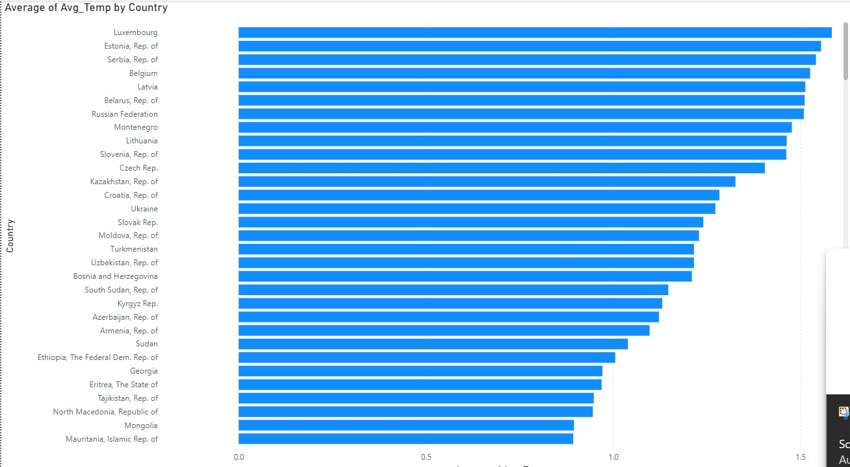

**Inference :** Countries such as Luxembourg, Estonia, Serbia, Belgium, and Latvia have experienced the most significant temperature changes, with Luxembourg showing the highest average temperature increase. These notable rises in average temperatures indicate a pronounced warming trend, highlighting the impact of climate change across these regions.

4.How do yearly average temperature changes compare between developed and developing countries?

AverageTempChange_Developed_Country =

CALCULATE(

AVERAGE(Climate_2[Avg_Temp]),

Climate_2[Classification] = "Developed"

)

AverageTempChange_Developing_Country =

CALCULATE(

AVERAGE(Climate_2[Avg_Temp]),

Climate_2[Classification] = "Developing"

)

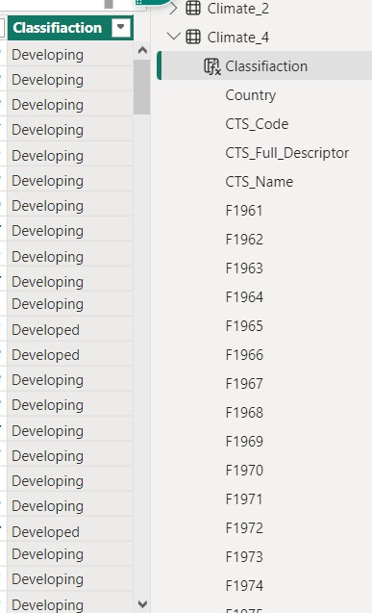

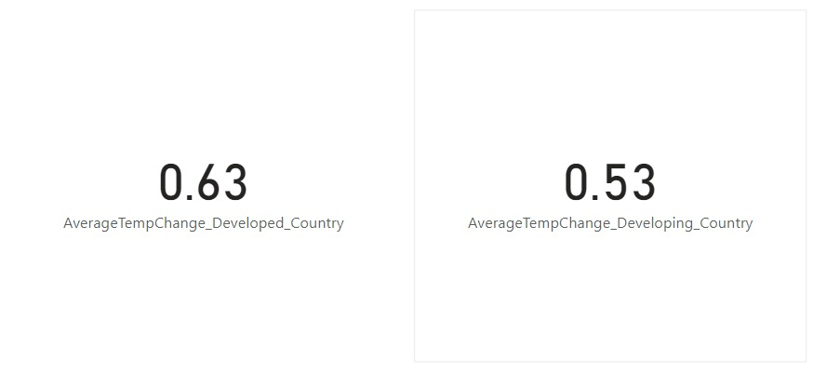

**Inference:** Developed countries have a higher average temperature change of 0.63°C compared to 0.53°C in developing countries, showing a difference of 0.10°C.

**5.Are temperature changes more severe in landlocked countries compared to coastal nations?**

Landlocked_Coastal =

SWITCH(

TRUE(),

Climate_2[Country] IN {"Afghanistan", "Armenia", "Austria", "Azerbaijan", "Bolivia", "Botswana", "Burkina Faso", "Burundi", "Central African Rep.", "Chad", "Czech Rep.", "Hungary", "Kazakhstan", "Kyrgyz Rep.", "Laos", "Lesotho", "Liechtenstein", "Luxembourg", "Malawi", "Mali", "Moldova", "Mongolia", "Nepal", "Niger", "North Macedonia", "Paraguay", "Rwanda", "San Marino", "Serbia", "Slovak Rep.", "South Sudan", "Swaziland", "Switzerland", "Tajikistan", "Turkmenistan", "Uganda", "Uzbekistan", "Zambia", "Zimbabwe"}, "Landlocked",

"Coastal"

)

AverageTempChange_Landlocked_Countries =

CALCULATE(

AVERAGE(Climate_2[Avg_Temp]),

Climate_2[Landlocked_Coastal] = "Landlocked"

)

AverageTempChange_Coastal_Countries =

CALCULATE(

AVERAGE(Climate_2[Avg_Temp]),

Climate_2[Landlocked_Coastal] = "Coastal"

)

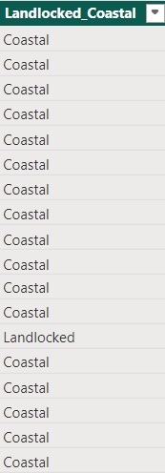

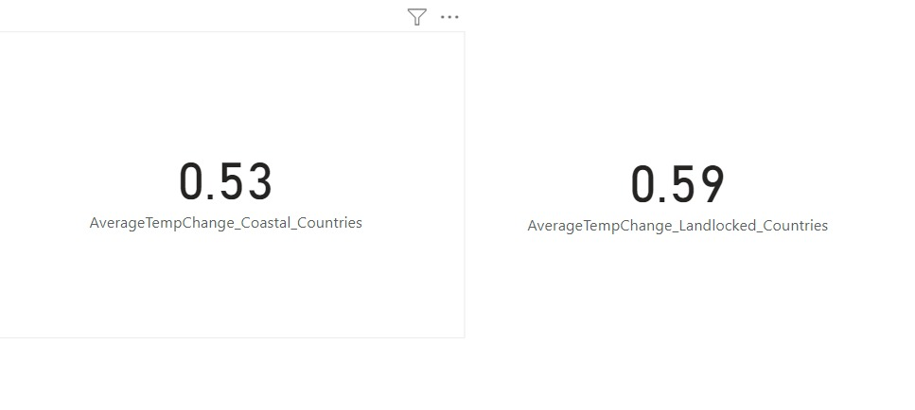

**Inference:** Temperature changes are more severe in landlocked countries, with an average increase of **0.59°C**, compared to **0.53°C** in coastal nations. This indicates that landlocked countries experience greater temperature fluctuations. The difference of **0.06°C** suggests that geographical factors may influence climate impacts, potentially due to limited access to moderating oceanic influences.

**6.What are the top 10 countries that have shown consistent annual increases in temperature?**

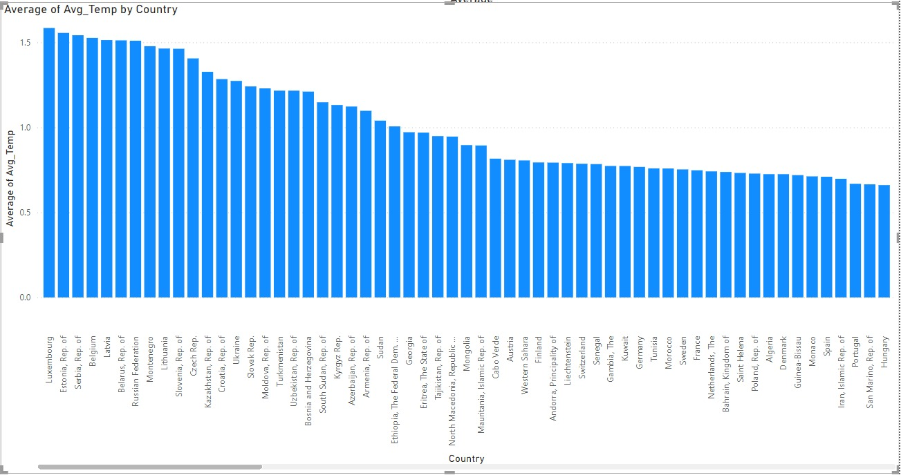

**Inference:** Based on the provided data, the top 10 countries that have shown consistent annual increases in temperature are Luxembourg, Estonia, Serbia, Belgium, Latvia, Belarus, the Russian Federation, Montenegro, Lithuania, and Slovenia. These countries exhibit the highest average temperatures, indicating a significant trend in rising temperatures over the years.

7.How do temperature changes differ between the Northern and Southern Hemispheres?

Hemisphere =

SWITCH(

TRUE(),

Climate_2[Country] = "Canada", "Northern",

Climate_2[Country] = "United States", "Northern",

Climate_2[Country] = "Germany", "Northern",

Climate_2[Country] = "United Kingdom", "Northern",

Climate_2[Country] = "China, P.R.: Mainland", "Northern",

Climate_2[Country] = "Japan", "Northern",

Climate_2[Country] = "Australia", "Southern",

Climate_2[Country] = "Argentina", "Southern",

Climate_2[Country] = "Brazil", "Southern",

Climate_2[Country] = "South Africa", "Southern",

BLANK() // Default for countries not classified yet

)

AverageTempChange_Northern =

CALCULATE(

AVERAGE(Climate_2[Avg_Temp]),

Climate_2[Hemisphere] = "Northern"

)

AverageTempChange_Southern =

CALCULATE(

AVERAGE(Climate_2[Avg_Temp]),

Climate_2[Hemisphere] = "Southern"

)

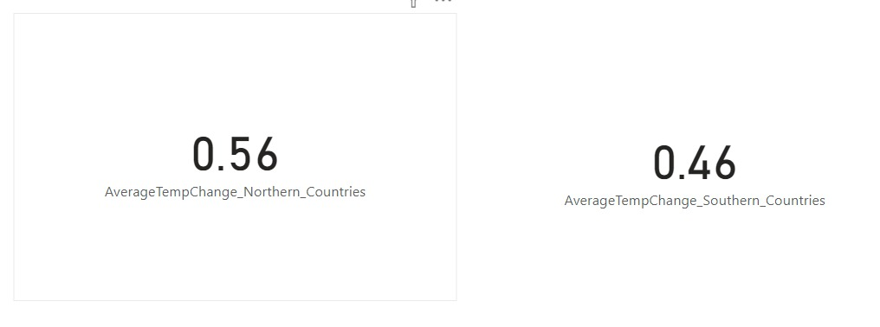

**Inference:** The analysis of temperature changes reveals that Northern Hemisphere countries have an average temperature increase of 0.56°C, while Southern Hemisphere countries shows lower increase of 0.46°C. This indicates that the Northern Hemisphere is experiencing a more significant rise in temperatures compared to the Southern Hemisphere**.**

**8.Is there any relationship between the size of a country (land area) and its temperature change ?**

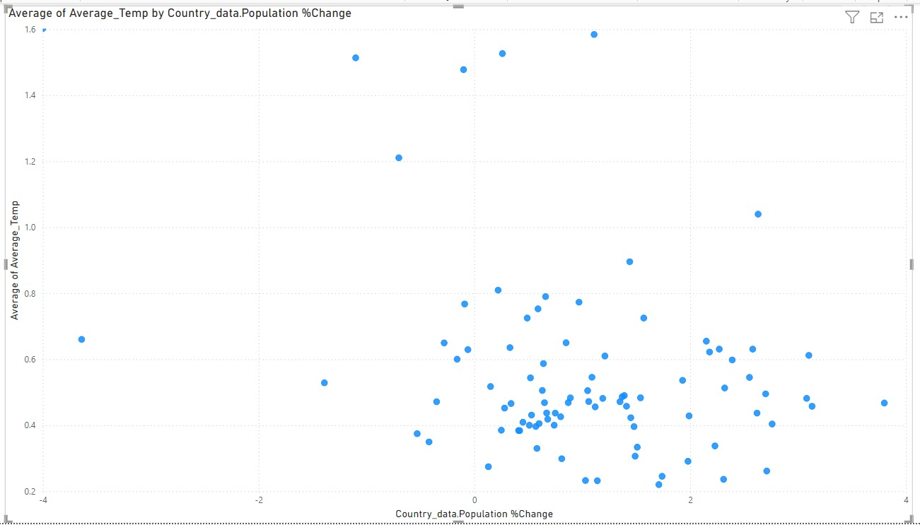

**Inference:** From the scatter plot analysis, it is evident that there is no strong correlation between population percentage change and average temperature change, as the points are widely dispersed without a clear pattern.

**9.How did temperature changes accelerate or decelerate during certain decades (e.g., 1980-1990, 2000-2010)?**

YearlyDeviation =

'Climate_7'[Temperature_Change] -

CALCULATE(

MAX('Climate_7'[Temperature_Change]),

FILTER(

'Climate_7',

'Climate_7'[Country] = EARLIER('Climate_7'[Country]) &&

'Climate_7'[Year] = EARLIER('Climate_7'[Year]) - 1

)

)

Anomaly = IF(ABS([YearlyDeviation]) > 2, "Anomaly", "Normal"

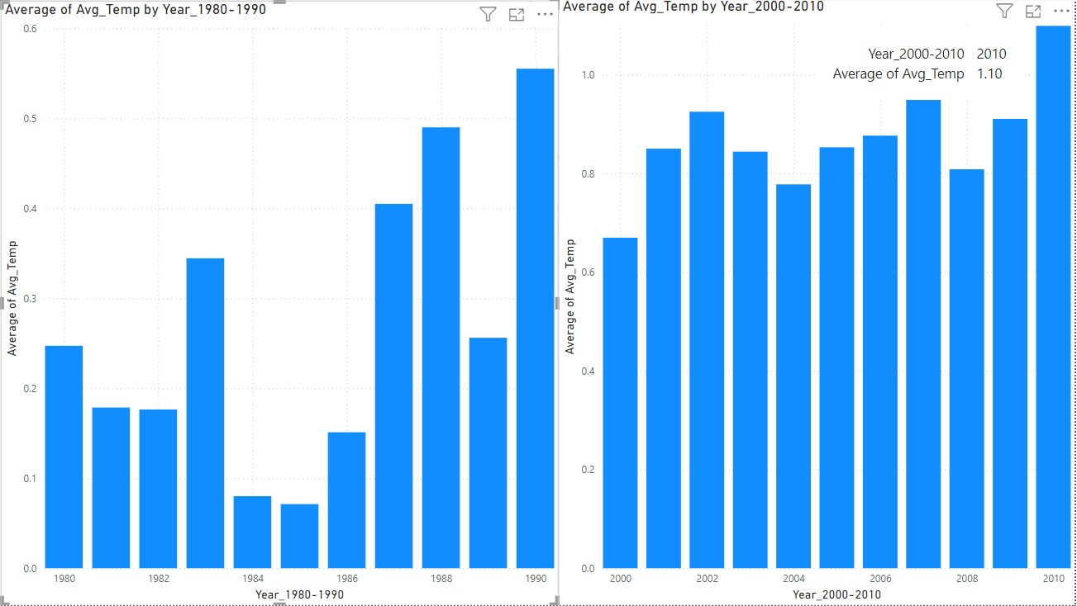

**Inference**: The charts indicate a significant rise in average temperatures over the decades, with a clear upward trend from the 1980s to the 2000s. This suggests a potential trend of global warming. The data highlights the importance of monitoring temperature changes to understand climate impacts better.